Homework For GP1 (Optical Part)

1. A electro-magnetic wave is specified by the following function (in SI unit):

****

Find (a) the direction along which the electric field oscillates, (b) the scalar value of the amplitude of the E-field, (c) the direction of the propagation of the wave, (d) the propagation number (or wave vector value) and wavelength, (e) the frequency and angular frequency, (f) the speed. (g) the irradiance *I.*

2． Given 3 harmonic waves, , where φ are 0, π/3, 2/3π. Find the resultant wave which is a superposition of the three harmonic wave.

3. Given two waves:

 and  (Here , not the unit vector long x-direction)

Please find out the phase difference between the two waves and which one is leading.

4. and are two E-M waves in vacuum and  where  is much smaller than . Show that where .

5． ( Hecht’ 3.10) The time average of some function over an interval of time is given by:



if τ=2π/ω is the period of a harmonic function, show that:

and  when T=τ, and T>>τ.

6. Hecht’s 3.14:

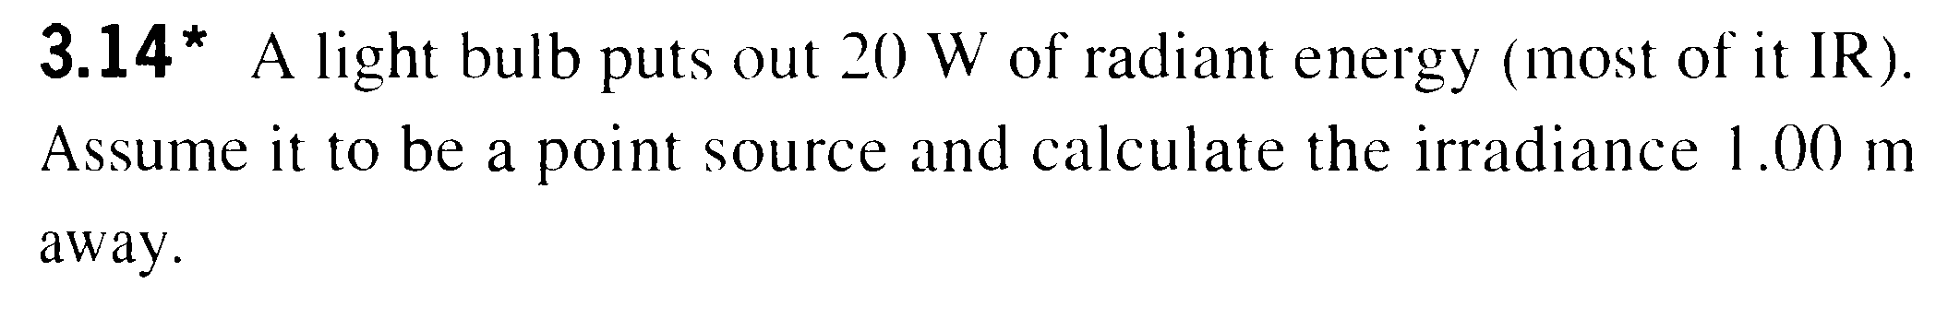

7. Hecht’s 3.23:

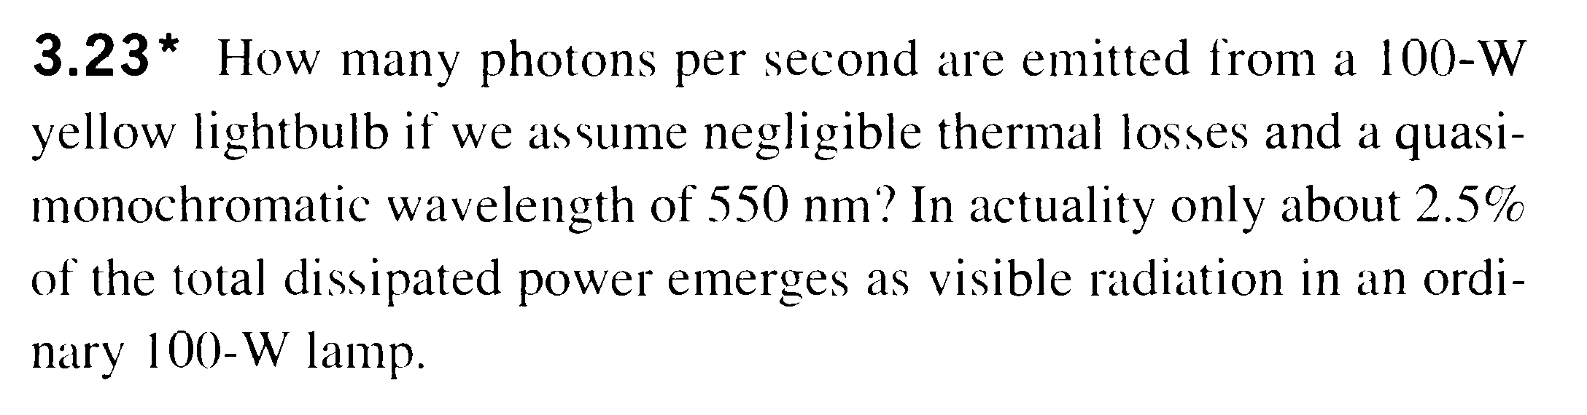

(some more for your practice purpose, no need to hand in these: Hecht’s 2.14, 2.23, 2.32, 2.37, 2.41, 2.42, 3.16, 3.17)